Name:

|  |  |  |
| --- | --- | --- |
| **Calculator Free** | **/32** | **%** |
| **Calculator Assumed** | **/24** | **%** |
| **Total** | **/56** | **%** |

**Mathematics Methods, Year 11, 2018**

**Test 4 – Indices, Index laws and Exponential functions.**

32 minutes working time.

**Calculator Free Section** (no notes, no calculators)

SCSA Formula sheet allowed

**Question 1 [10 marks: 2, 3, 2, 3]**

Simplify each of the following expressions, giving all answers with positive indices.

$\frac{30x^{5}y^{7}}{-15x}$

${\left(\frac{3x^{-2}}{y^{3}}\right)}^{-3}$

$\frac{{\left(8x^{6}y^{-12}\right)}^{\frac{1}{3}}}{-2x}$

$\frac{5^{2n+3}+{\left(5^{n}\right)}^{2}}{5^{2n}}$

**Question 2 [5 marks = 2, 3 marks]**

Solve for $x$

$x^{\frac{1}{4}}+10=12$

b) ${{(2}^{x})}^{2}-5{(2}^{x})+4=0$

**Question 3 [4 marks: 2, 2]**

Solve for $x$

${27}^{x-2}=\frac{1}{81}$

$2×\sqrt[3]{x}=3$

**Question 4 [5 marks: 2, 3]**

Starting with the base exponential equation $y=3^{x}$, list the transformations that have taken place to reach:

$y=2 x{ 3}^{x}+1$

$y=-3^{x+2}$

**Question 5 [4 marks: 2, 2]**

Determine the equation of the given exponential curves.

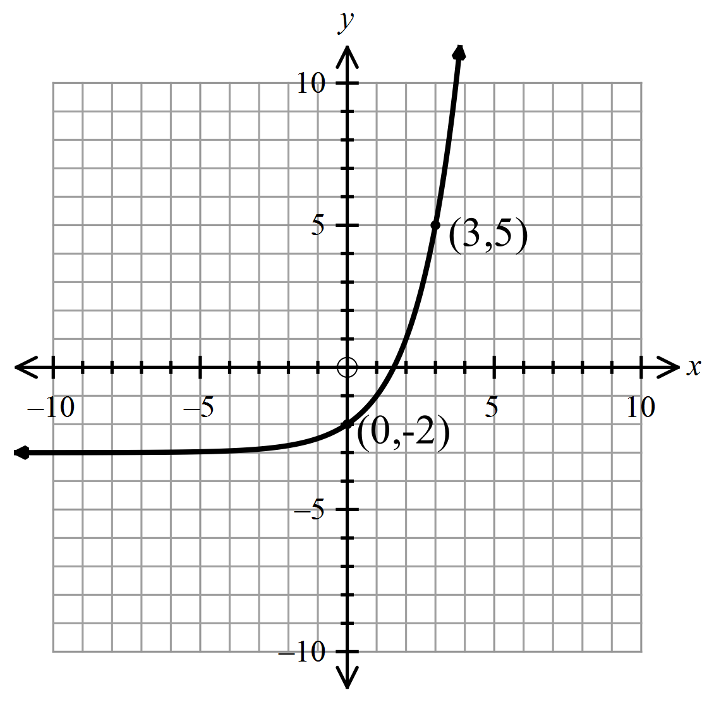

a)

b)

**b)**

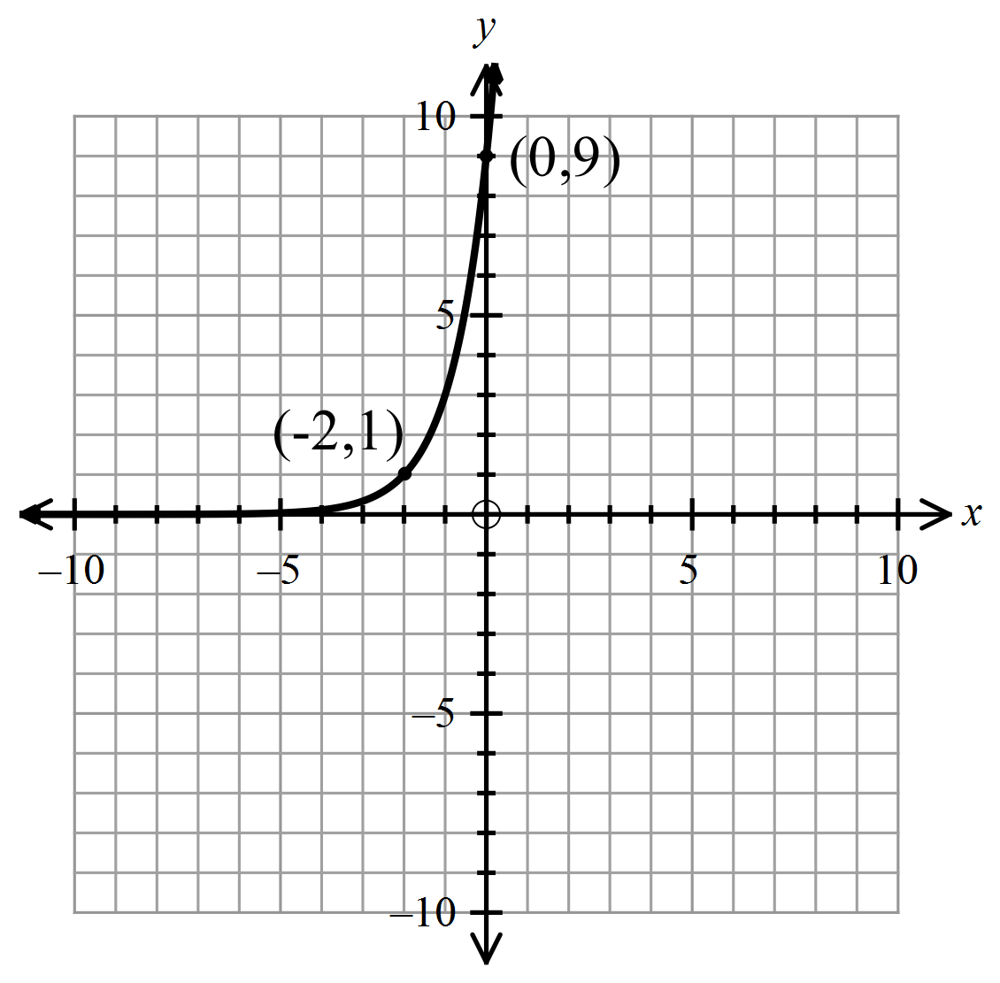

**Question 6 [4 marks: 2, 2]**

Sketch each of the following curves on the axes provided. Indicate clearly the intercepts and the asymptotes.

1. $y=3\left(2^{x}\right)$ b)

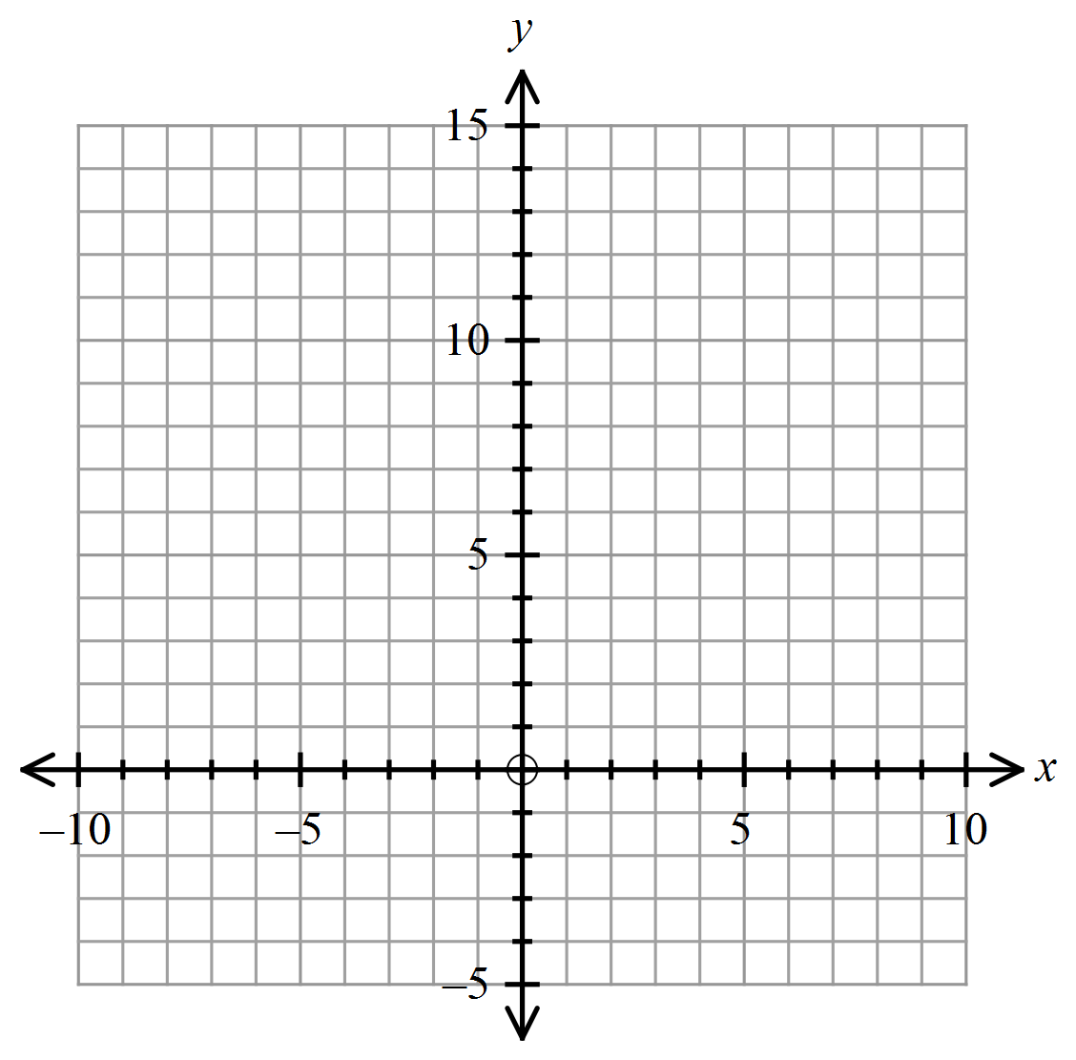

Name:

|  |  |  |
| --- | --- | --- |
| **Total** | **/24** | **%** |

**Mathematics Methods, Year 11, 2018**

**Test 4 – Indices, Index laws and Exponential functions.**

**Calculator Assumed Section** (notes allowed) 26 minutes working time.

SCSA Formula sheet and calculators allowed

THIS PAGE IS DELIBERATELY LEFT BLANK

**Question 7 [5 marks:1, 2, 2]**

Suppose the amount of ‘fizz’ in an opened bottle of cool drink deceases each day according to the formula  where A units is the amount of ‘fizz’ and n is the number of days after it is opened.

1. How much ‘fizz’ is in the unopened bottle?
2. How much ‘fizz’ would be left after 3 days? Give your answer in scientific notation.
3. How long before it has less than 1% of the original ‘fizz’? Give your answer to the nearest day.

**Question 8 [4 marks: 2, 2]**

The pressure, P, in the earth’s atmosphere decreases exponentially as you rise above the surface. The pressure in millibars at a height of h kilometres is given approximately by the function

$P\left(h\right)=1000x{0.8825}^{h}$

1. Find the pressure at a height of 5km (to the nearest millibar) .

1. Find the height at which the pressure is 400 millibars (to the nearest metre)

Question 9 [3 marks: 2, 1]

In the year 2000, in an African game park it was estimated that there were approximately 700 wildebeest and that their population was increasing at 3% per year.

At the same time, in the park there were approximately 1850 zebras and the population was decreasing at the rate of 4% per year.

1. Write an expression for both functions and then enter both in your calculator.

1. After how many years was the number of wildebeest greater than the number of zebras?

**Question 10 [6 marks: 3, 3]**

The number of bacteria N, in a culture increases exponentially with time according to the rule

$N=ab^{t}$, where time t is measured in hours.

When observations started, there are 1000 bacteria, and five hours later there were 10000 bacteria.

1. Find the values of a and b. Give your answer correct to 4 significant figures.
2. Find, to the nearest minute, when there were 5000 bacteria.

**Question 11 [6 marks: 2, 1, 3]**

The number of Little Penguins on Penguin Island in WA has been declining. At the start of 2018 there were only 900 Little Penguins on the island after double that number being counted on the island five years ago, ie. at the start of 2013.

1. Verify that the population of these little penguins on the island could be modelled by the equation, $P=1800{(0.87)}^{t},$ where $t$ is the number of years after the start of 2013.
2. Estimate the number of little penguins (to the nearest 10) at the end of 2025.
3. At the start of which year, will the number of Little Penguins have reached the critically endangered level of 200.